Переделка CMD в формат ISO (YYYY-MM-DD)

Меняем CMD, оставляя одну строку. Меняем --delete-target-dir вместо --hive-import --hive-database s_dwh --hive-table cardtrnoptype_sdim.

--hive-overwrite в конце тоже удаляем:

было:

$PMRootDir/Scripts/quotes_insert.pl 'ssh etladmin@bda11node06 ^sqoop import --connect \^jdbc:oracle:thin:@(DESCRIPTION=(ADDRESS_LIST=(ADDRESS=(PROTOCOL=TCP)(HOST=exa1-scan)(PORT=1521))(ADDRESS=(PROTOCOL=TCP)(HOST=exa2-scan)(PORT=1521)))(CONNECT_DATA=(SERVICE_NAME=DWSTPROD_TAF)))\^ --username $DWH_USER --password $DWH_PASS --query \^select UK, CCODE, NAME, CARDTRNOPTYPEGROUP_UK, DELETED_FLAG, DEFAULT_FLAG, JOB_INSERT, JOB_UPDATE, to_char(AS_OF_DAY, ~dd.mm.yyyy~) as AS_OF_DAY, DWSCMIX from DWH.CARDTRNOPTYPE_SDIM where deleted_flag=~N~ and \\\$CONDITIONS\^ -m 1 --compression-codec GZIP --as-parquetfile **--hive-import --hive-database s_dwh --hive-table cardtrnoptype_sdim** --target-dir /storage/s_dwh/db/cardtrnoptype_sdim/ **--hive-overwrite**^'

стало:

$PMRootDir/Scripts/quotes_insert.pl 'ssh etladmin@bda11node06 ^sqoop import --connect \^jdbc:oracle:thin:@(DESCRIPTION=(ADDRESS_LIST=(ADDRESS=(PROTOCOL=TCP)(HOST=exa1-scan)(PORT=1521))(ADDRESS=(PROTOCOL=TCP)(HOST=exa2-scan)(PORT=1521)))(CONNECT_DATA=(SERVICE_NAME=DWSTPROD_TAF)))\^ --username $DWH_USER --password $DWH_PASS --query \^select UK, CCODE, NAME, CARDTRNOPTYPEGROUP_UK, DELETED_FLAG, DEFAULT_FLAG, JOB_INSERT, JOB_UPDATE, to_char(AS_OF_DAY, ~YYYY-MM-DD~) as AS_OF_DAY, DWSCMIX from DWH.CARDTRNOPTYPE_SDIM where deleted_flag=~N~ and \\\$CONDITIONS\^ -m 1 --compression-codec GZIP --as-parquetfile **--delete-target-dir** --target-dir /storage/s_dwh/db/cardtrnoptype_sdim/^'

Удаляем строки :

Change group permissions:

hdfs dfs -chown etladmin:s_dwh_w /storage/s_dwh/db/cardtrnoptype_sdim/*

Add ACL read permission:

hdfs dfs -setfacl -R --set user::rwx,group::rwx,group:s_dwh_r:r-x,other::--- /storage/s_dwh/db/cardtrnoptype_sdim

Переделываем запрос из * в перечисление полей, преобразовывая даты:

*-- to_char(AS_OF_DAY, ~YYYY-MM-DD~) as AS_OF_DAY*

*-- to_char(START_TIME, ~YYYY-MM-DD HH24:MI:SS~) as START_TIME*

select * from DWH.CHANNEL_HDIM;

select UK, CCODE, ADDITIONAL_CCODE, NAME_RUS, NAME_ENG, NAME_SHORT, to_char(START_DATE, ~dd.mm.yyyy~) as START_DATE, to_char(END_DATE, ~dd.mm.yyyy~) as END_DATE, USER_UK, DELETED_FLAG, DEFAULT_FLAG, to_char(VALIDFROM, ~dd.mm.yyyy~) as VALIDFROM, to_char(VALIDTO, ~dd.mm.yyyy~) as VALIDTO, JOB_INSERT, JOB_UPDATE, to_char(AS_OF_DAY, ~yyyy-mm-dd HH24:MI:SS~) as AS_OF_DAY, DWSCMIX, CHANNELKIND_GK, SRC_CCODE, MODULE_UK from DWH.CHANNEL_HDIM

MANAGED_TABLE

Удаляем старую таблицу:

drop table `s_dwh.channel_hdim`

Создаем новую:

CREATE TABLE `s_dwh.CHANNEL_HDIM`(

`UK` string,

`CCODE` string,

`ADDITIONAL_CCODE` string,

`NAME_RUS` string,

`NAME_ENG` string,

`NAME_SHORT` string,

`START_DATE` string,

`END_DATE` string,

`USER_UK` string,

`DELETED_FLAG` string,

`DEFAULT_FLAG` string,

`VALIDFROM` string,

`VALIDTO` string,

`JOB_INSERT` string,

`JOB_UPDATE` string,

`AS_OF_DAY` string,

`DWSCMIX` string,

`CHANNELKIND_GK` string,

`SRC_CCODE` string,

`MODULE_UK` string)

ROW FORMAT SERDE

'org.apache.hadoop.hive.ql.io.parquet.serde.ParquetHiveSerDe'

STORED AS INPUTFORMAT

'org.apache.hadoop.hive.ql.io.parquet.MapredParquetInputFormat'

OUTPUTFORMAT

'org.apache.hadoop.hive.ql.io.parquet.MapredParquetOutputFormat'

LOCATION

'hdfs://bda11/storage/s_dwh/db/CHANNEL_HDIM'

TBLPROPERTIES (

'COLUMN_STATS_ACCURATE'='false',

'avro.schema.url'='hdfs://bda11/storage/s_dwh/db/CHANNEL_HDIM/.metadata/schemas/1.avsc',

'kite.compression.type'='snappy',

'numFiles'='0',

'numRows'='-1',

'rawDataSize'='-1',

'totalSize'='0',

'transient_lastDdlTime'='1527848676')

Запускаем CMD

**ПРИМЕЧАНИЕ:**

Если при создании таблицы пишем просто CREATE TABLE то создается MANAGED таблица:

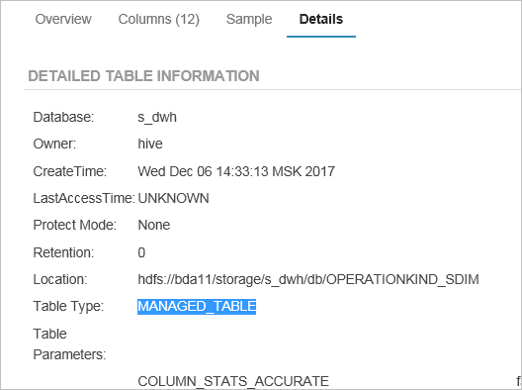

и при ее удалении удаляется папка HDFS с файлами этой таблицы

Если при создании указывается CREATE **EXTERNAL** TABLE то при удалении папка с файлами не удалиться.

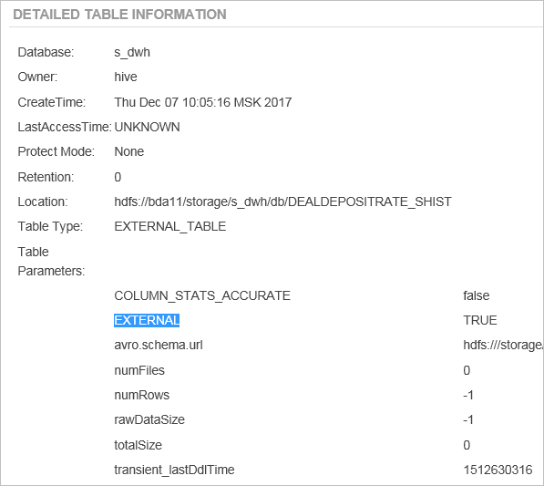

MANAGED_TABLE MANAGED_TABLE MANAGED_TABLE MANAGED_TABLE